Marriott.com Hotel Web Sites

Residence Inn Breakfast & Residence Inn Mix Photography

- Select up to four of the Residence Inn breakfast photos and up to two of the Residence Inn Mix photos.
The brand-approved captions shown are the captions that will be displayed.
- E-mail completed form to Design.HWS@marriott.com

PART 1: Hotel Information

Property/Hotel Name: Residence Inn Lubbock Southwest
MARSHA code: LBBRW
Hotel Contact (employee name): Luz Cuevas
E-mail address: luz.cuevas@baywoodhotels.com

PART 2: Image Submission Information

Residence Inn Breakfast Photography:
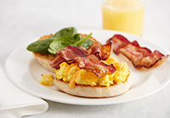

Enjoy fresh ingredients for your perfect breakfast. Choose from scrambled eggs or scrambled egg whites and then layer on andouille sausage or bacon and spinach.
ri_food01
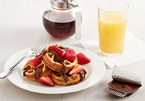

When it comes to waffles, the toppings make all the difference, from sweet with Nutella® or mango sauce to savory with peanut butter, sliced bananas and bacon. Make a mini waffle, and make it yours
ri_food02

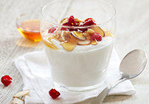

Enjoy Chobani® flavored Greek low-fat yogurt, Dannon Light & Fit® or Oikos® plain Greek yogurt. Add your signature with our delicious mix-ins like walnut pieces, granola, mango sauce or fresh fruit.
ri_food04

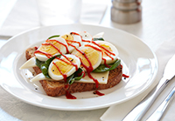

With our extensive selection of ingredients, eggs meet endless possibilities. Try yours on whole grain toast with Havarti cheese, spinach and Sriracha hot sauce.
ri_food05

RI Mix Photography:

NOTE: Only select one of the “Residence Inn Mix” photos (“with alcohol” or “no alcohol”)


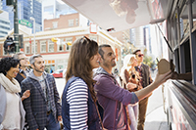
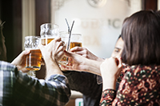

Join us at the Residence Inn Mix every Monday, Tuesday and Wednesday evening. It’s a fun and relaxing way to unwind, socialize, and connect. Enjoy complimentary premium beer and wine, plus appetizers. This photo is a representation of the hotel's facilities and amenities.
ri_mix_phototour03

Join us at the Residence Inn Mix every Monday, Tuesday and Wednesday evening. It’s a fun and relaxing way to unwind, socialize, and connect. Enjoy complimentary beverages and appetizers. This photo is a representation of the hotel's facilities and amenities.
ri_mix_phototour04

Get a taste of the hottest food scene right outside our door. One of our area’s best food trucks will stop by the hotel on alternating Wednesday evenings providing guests with the opportunity to purchase great food. The refreshing beverages are on us! This photo is a representation of the hotel's facilities and amenities.
ri_mix_phototour07

